

Cost Estimation

Document Understanding (DU)

Prepared by Sinchana Ramesh | 12 June 2024

@Copyright 2022 Version 1 – All Rights Reserved

**Table of Contents**

1 OCI Document Understanding 2

1.1 Cost Estimation 2

1.2 Key Points 2

1.3 Document Understanding monthly pricing examples 4

2 Azure Document Intelligence 4

2.1 Resources 4

2.2 Cost case 4

2.3 Document Intelligence monthly pricing examples 4

# OCI Document Understanding

## Cost Estimation

Below are the cost estimates for using various services in Document Understanding.

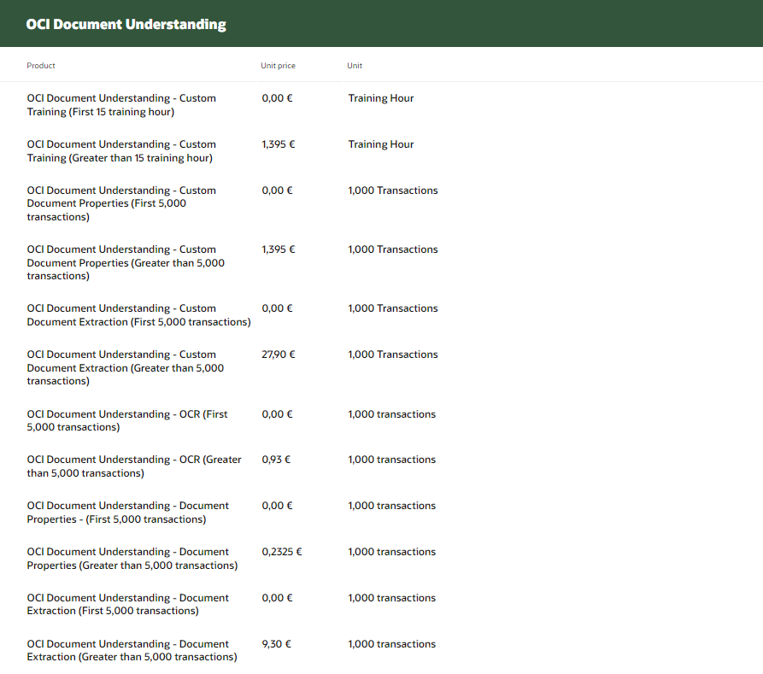

## Key Points

* Oracle Cloud AI Service Document Understanding First 5,000 transactions has a free pricing tier.
* For the free pricing tier, you may only use 5,000 transactions of this cloud service.
* Five thousand (5000) transactions per month will be provided at no cost, If you exceed this amount, you must pay for usage in accordance with the rate card pricing for this cloud service.
* Transaction usage is measured by calculating the number of transactions which is defined as one operation on one page in 1 transaction.
* 1 Transaction = $10.00 in USD(Each transaction costs you $10.)
* The below would be the cost charges if you exceed more than 5000 transactions a month.

i.e. for 1000 transactions.

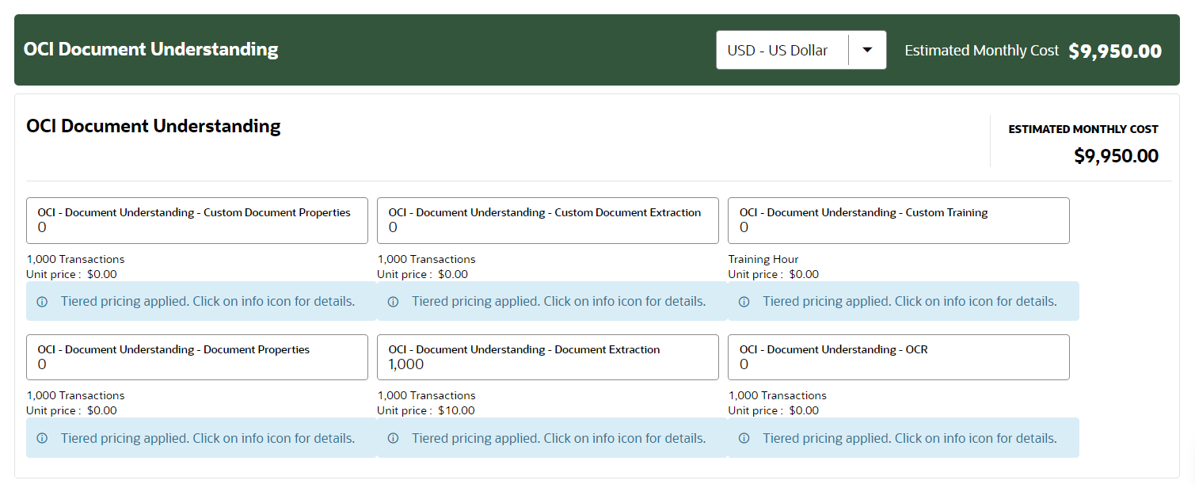

* There is a separate charge for OCR, as Document Understanding uses OCR to extract information.
* Each transaction costs you $1.00 for OCR.
* Below, are the charges for OCR. i.e. for 1000 transactions.

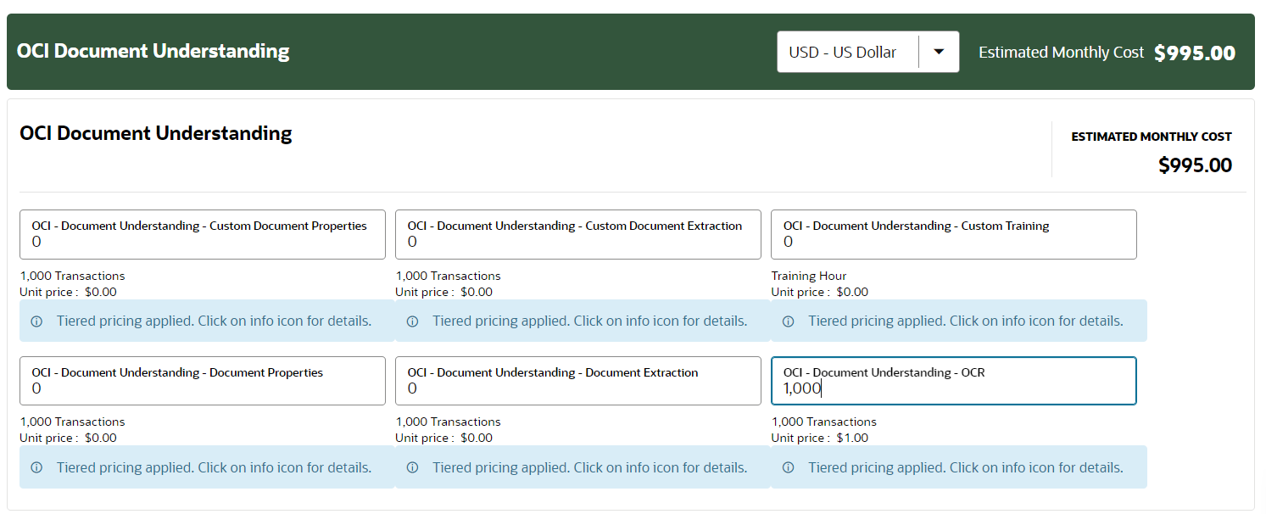

## Document Understanding monthly pricing examples

1. **Text extraction**

* Extract terms and timing schedule for commitments from 1,000 contracts per month, with each contract at 50 pages.
* Monthly cost for optical character recognition SKU:

1,000 contracts x (50 pages/contract) x ($1/1,000) images = $50

1. **Receipt processing**

* Extract text and key-value pairs from approximately 50,000 receipts per month to complete returns, with each receipt at 1 page long.
* Monthly cost for document extraction SKU:

50,000 documents x 1 page/document x ($10/1,000 pages) = $500

# Azure Document Intelligence

The resources and cost reductions for document intelligence are as follows

## Resources

* Azure Document Intelligence – prebuilt SKU(Layout) – USD 0.01/Page
* Azure Open AI – gpt-4-8k USD 0.0300/1000 tokens
* Free : Up to 500 pages included per month.

## Cost case

* Assume we have a document of 100 pages with an average of 1000 tokens per page. To simply the full document the total cost will be

**(USD 0.01/page * 100 pages) + (USD 0.0300/1000 tokens * 100 pages) = USD 4.00 / 100 page**

## Document Intelligence monthly pricing examples

* The monthly prices are as follows,



